On the day of the event:
- M-Sport will have a safety car available at the beginning of each stage, following the vehicle driven by J.Serderidis.
- In the safety car there will be the M-Sport E-Safety Engineer (at minimum).
  - All the safety equipment listed below will also be in the vehicle.
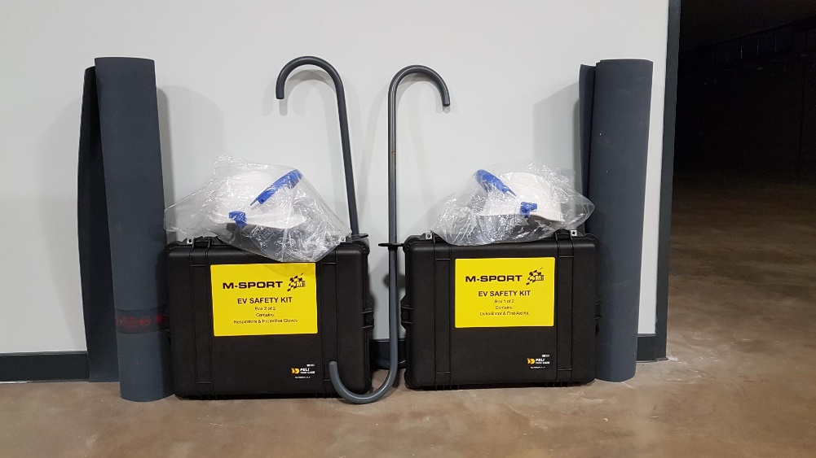
- The safety car will not enter the stage unless instructed by the stage commander.

Electric Vehicle Safety:
- M-Sport staff will have: an EV Safety Kit, EV Fire blanket, insulated tools, and insulated covers to deal with incidents. Safety cones will also be present to communicate the last known state of the car.
- The Crew, if they are able to extricate themselves from the car, will become the incident controllers.
- The Crew have insulated gloves, with PPE available in the car, and a red/green status board to communicate the last known state of the car.
- M-Sport staff and the Crew will follow FIA procedures to always ensure the status of the hybrid systems is communicated by the safety lights, the cone and/or the red/green board.
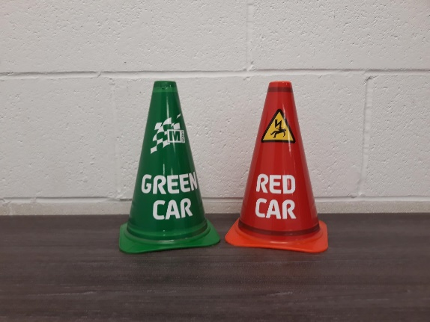

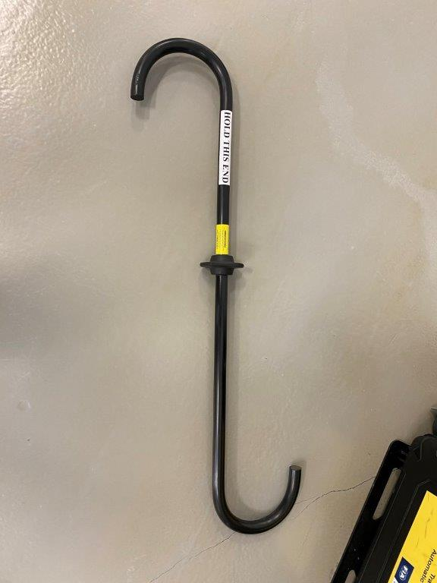
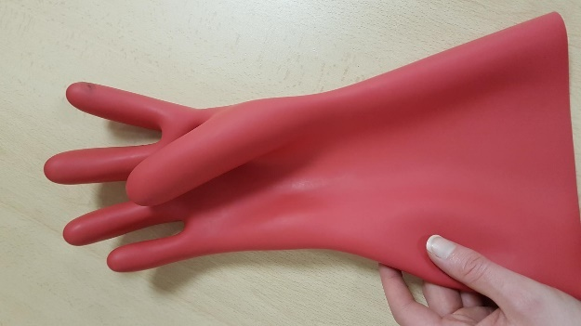

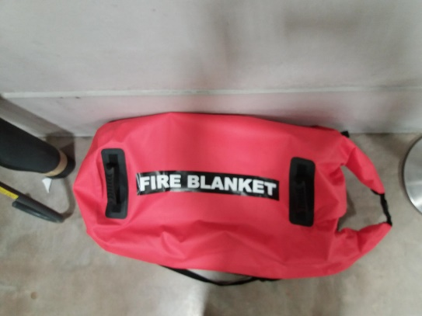

Light System
Green Lights:
- If a Rally1 car stops in the stage but is displaying constant green lights it can be treated the same as a non-hybrid car.
- The decision to stop the stage or allow it to continue is down to the stage commander.
- The hybrid system is safe and the Marshalls and spectators can touch the car.

Red Lights:
- If a Rally1 car stops in the stage but is displaying flashing red or no lights, the stage should be stopped.
- Event staff should only touch the car if there is an immediate danger to the crew and they have minimum insulated gloves and rescue hook PPE
- The stage controller will instruct the chase car to enter the stage and will take over the scene to assist the crew and determine the safety of the car
- Spectators must be kept away from the car
Stopping the system:
- The E-Stop switch in front of the windscreen will cut all 12V power to the car
- No power does not guarantee the hybrid system is safe
- If there are no safety lights, no cone and no red/green board the car should be assumed to be in an unsafe (red-light) state

